Pietro Ouro

CS120

Sayed shah

11/10/2020

Data Base Project 3

Abstract

Using the Microsoft Access to make data bases.

Introduction

In this project I learned how to construct a data base and use the MA a APP that I like a lot to use.

Methodology:

1.Fist I started creating the fields(name,last name,major,sport,age, and country. 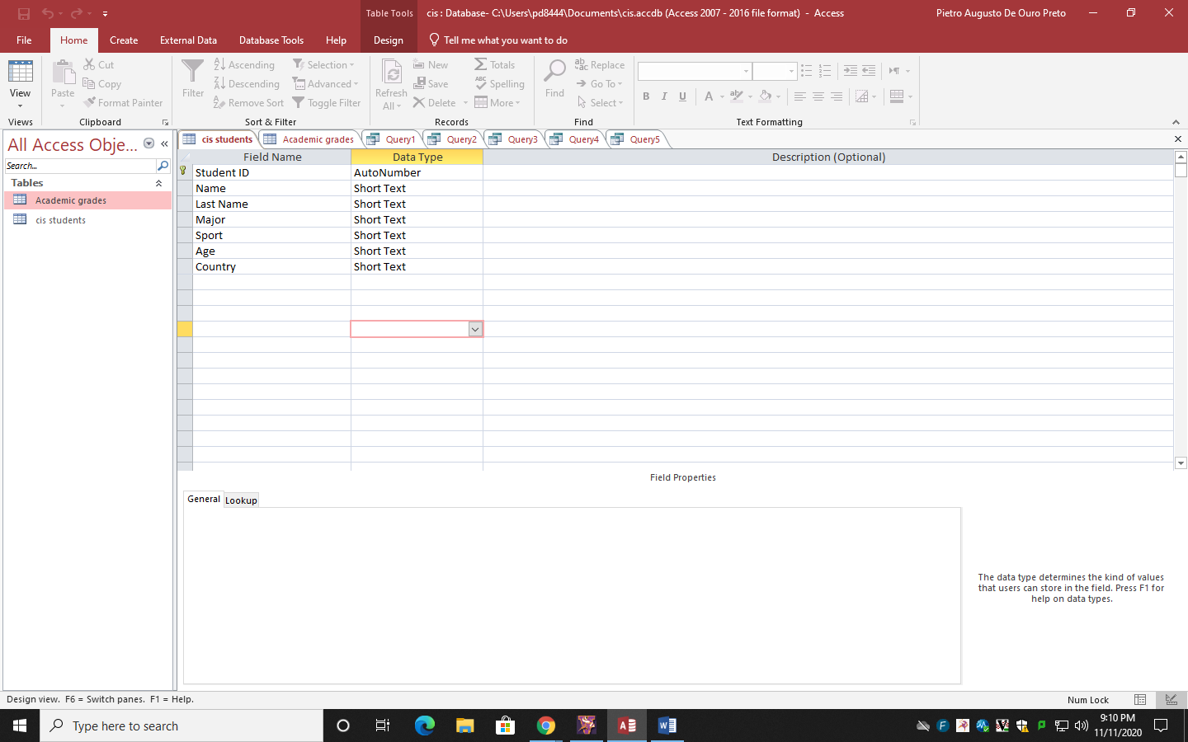

2. I filled the blank spaces with the informations.

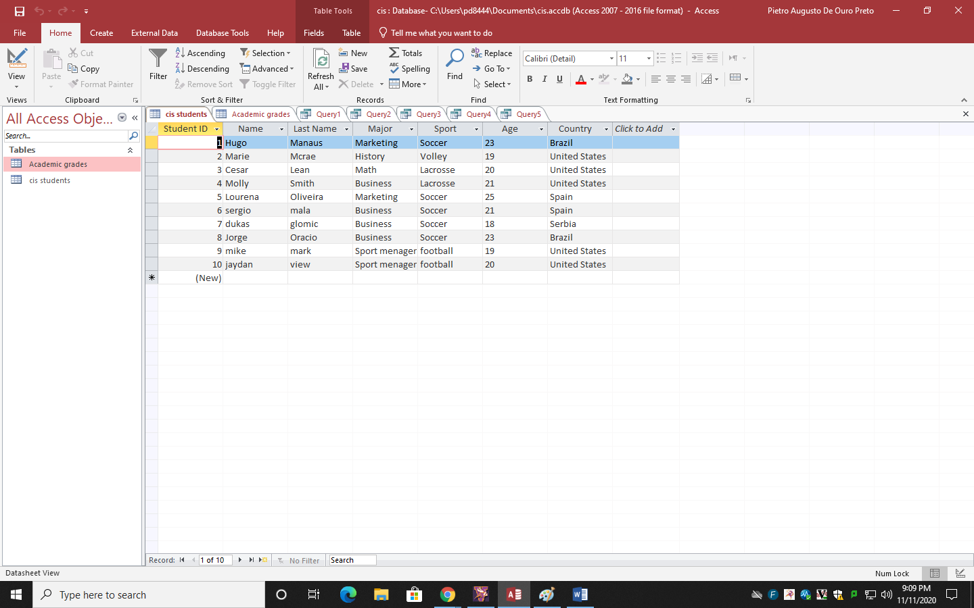

3.created another database with other fields(Gpa and students international).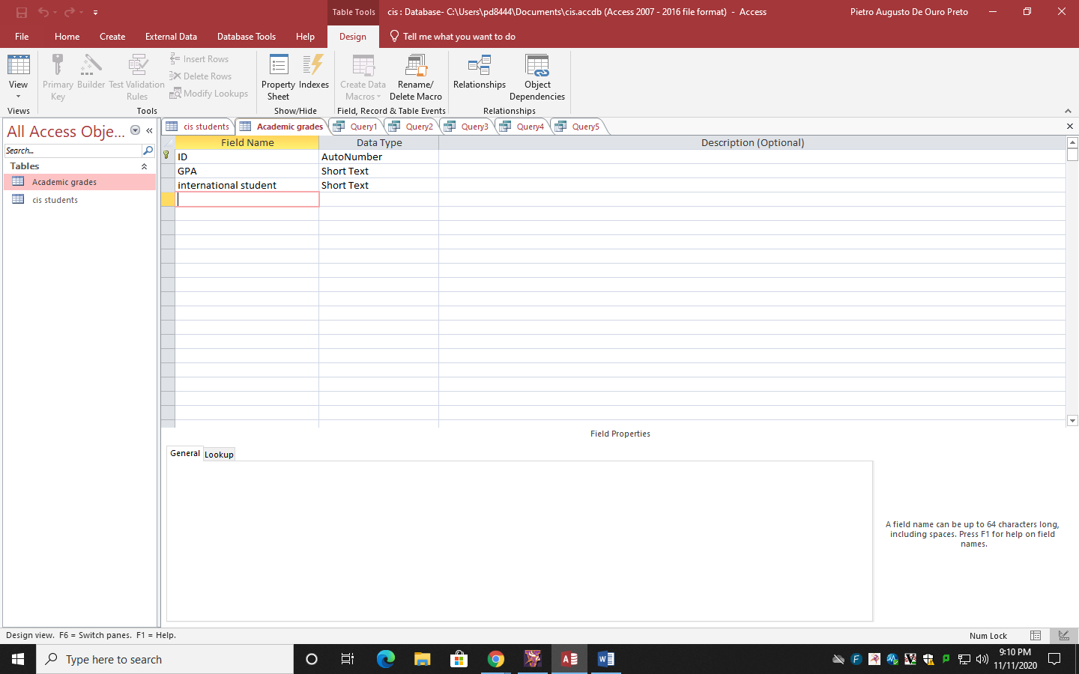

4 then I filled it with information too.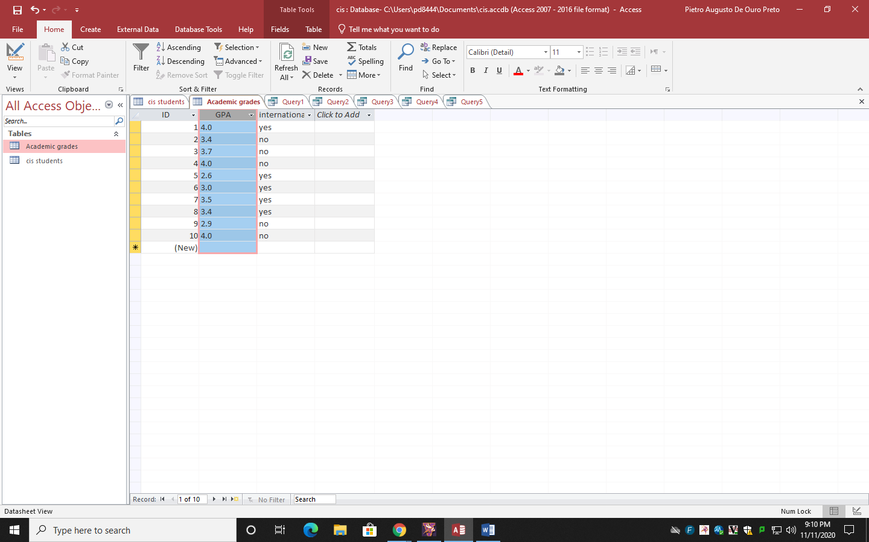5. I created a query and programmed to show the students with more or equal 3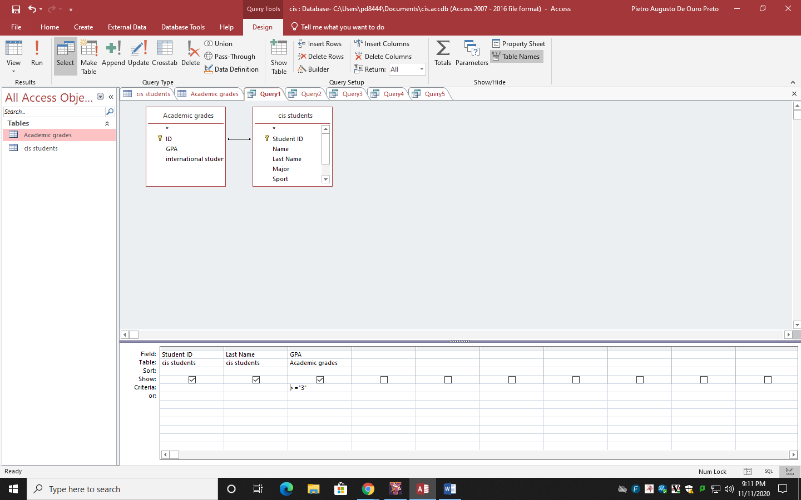

6 the result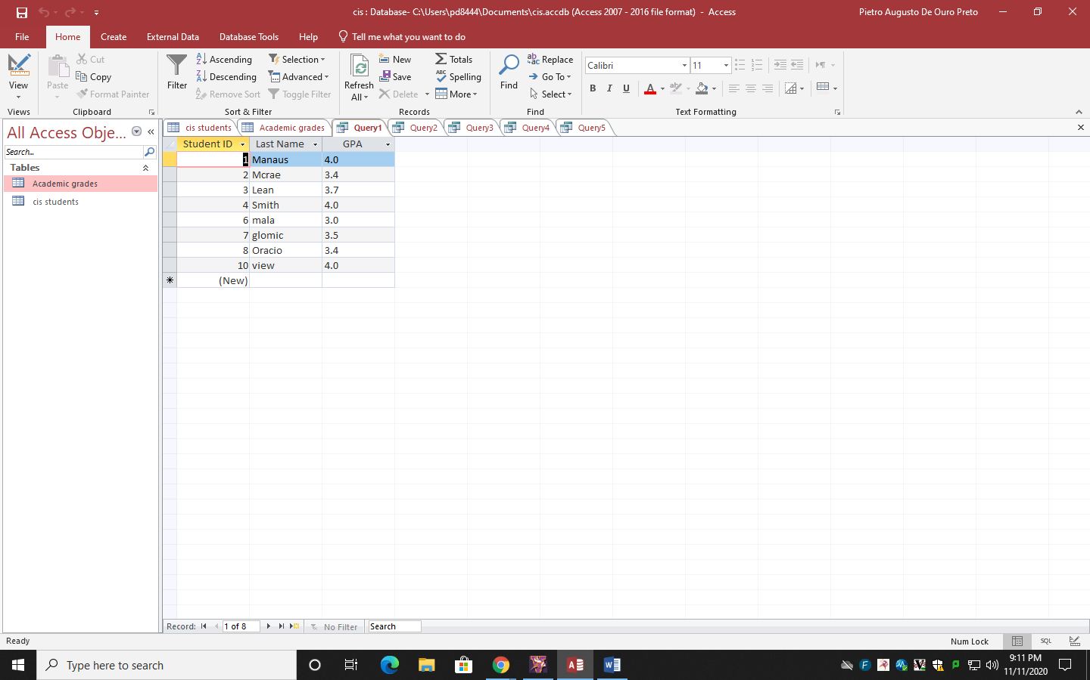7 I programmed the secound query to show just the business students.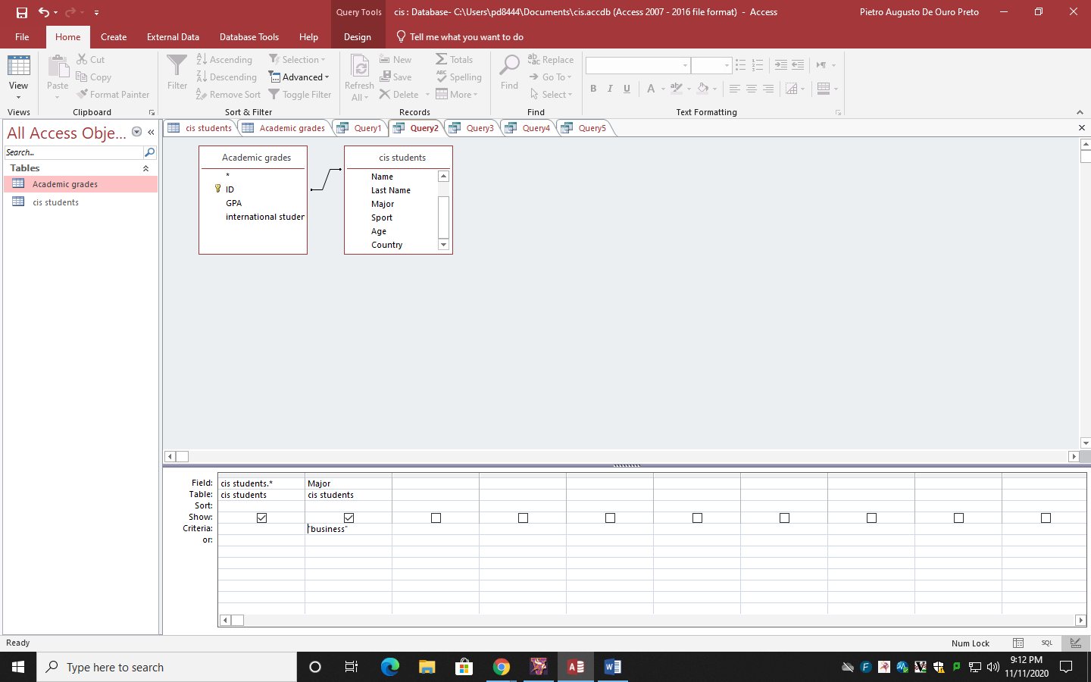

8. the result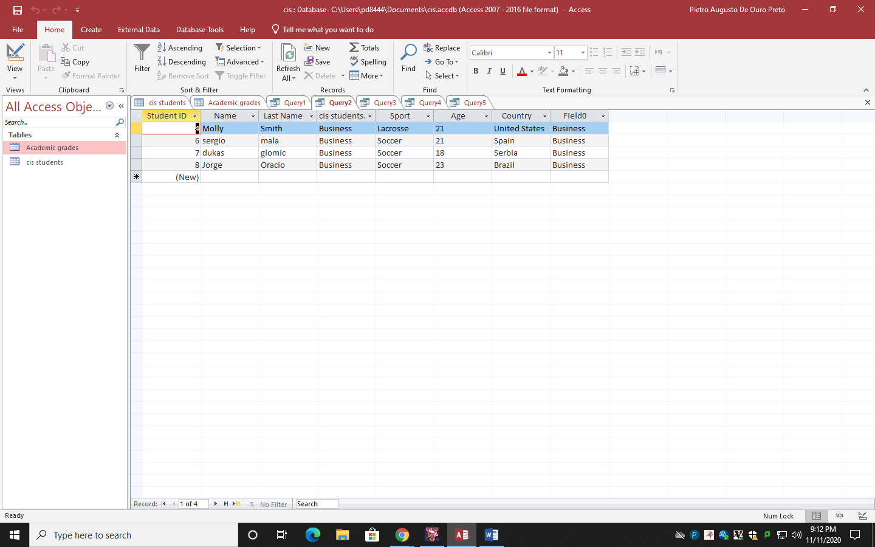9. I programmed the 3 query to show only brazilians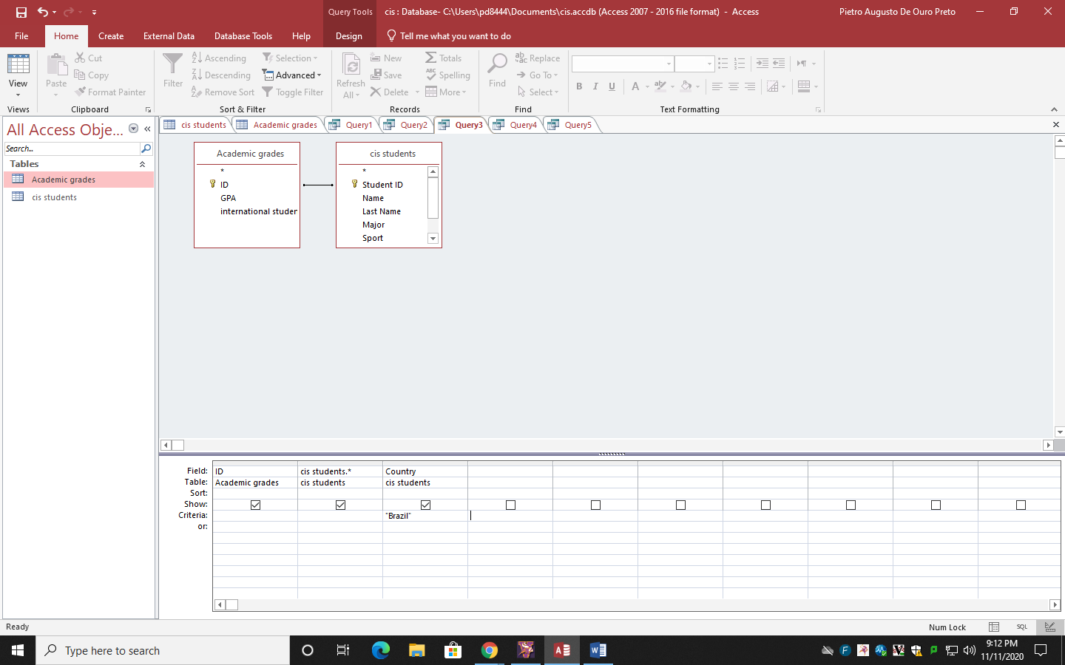

10. the result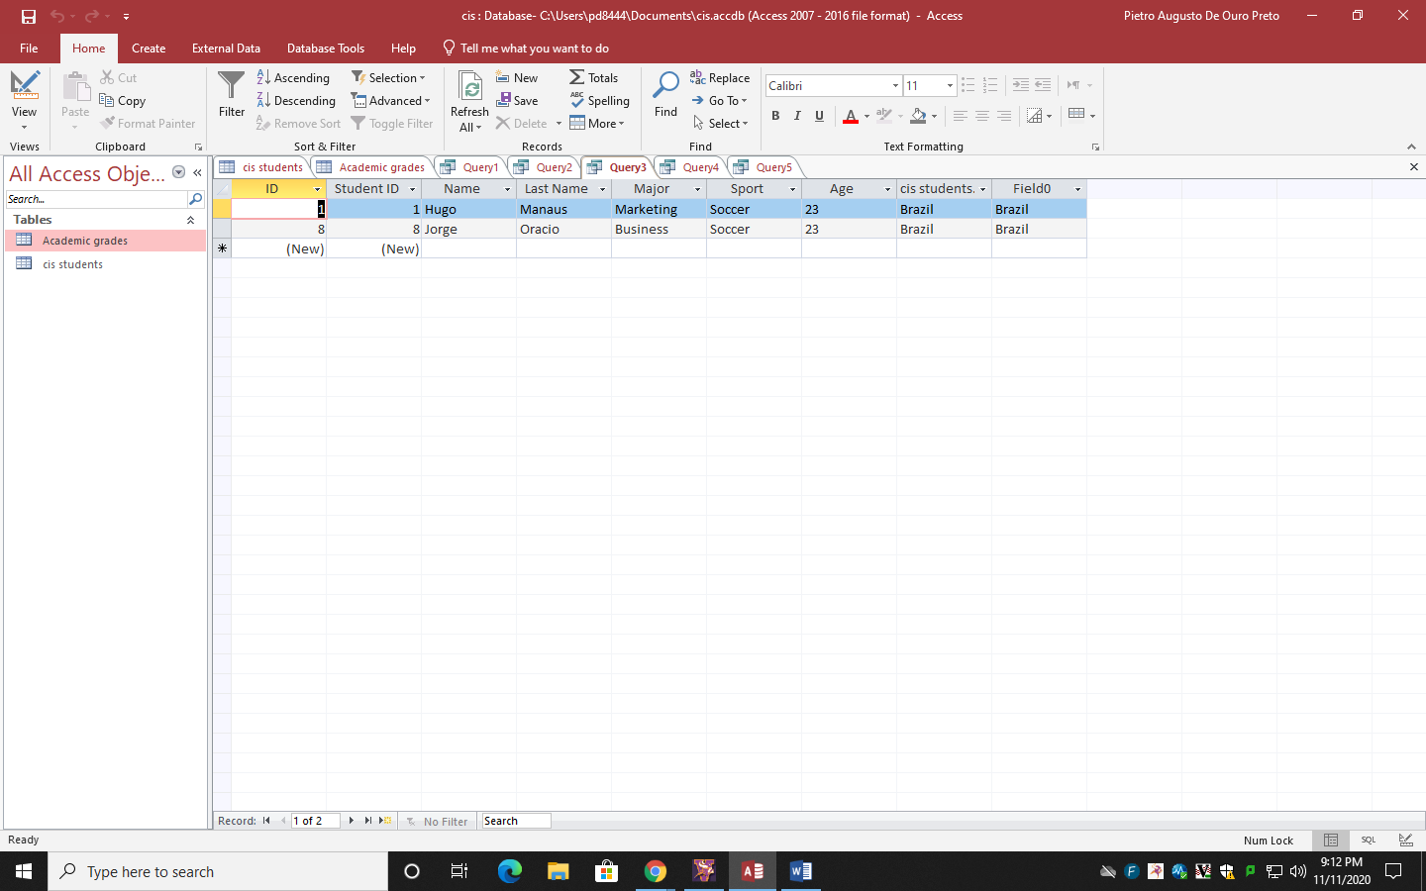11. fourty query was just the soccer players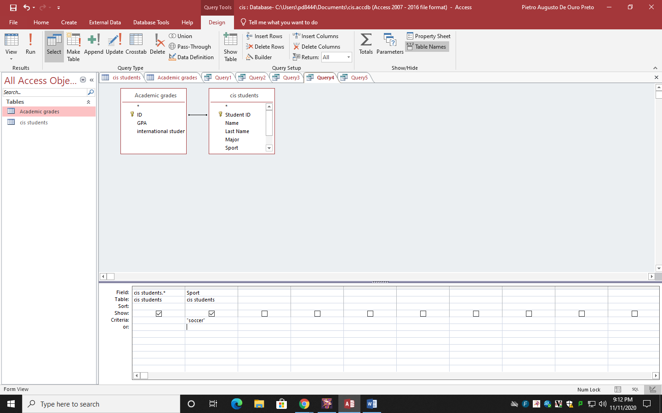

12. the result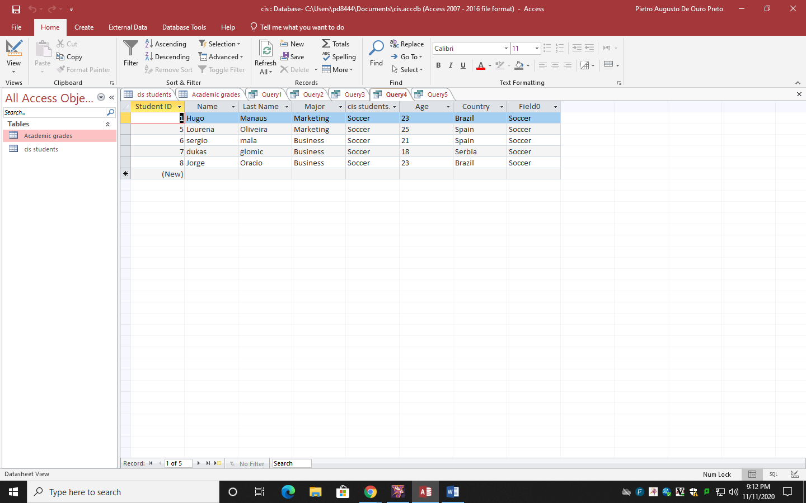

13.fifty query ,the students with more then 20 years old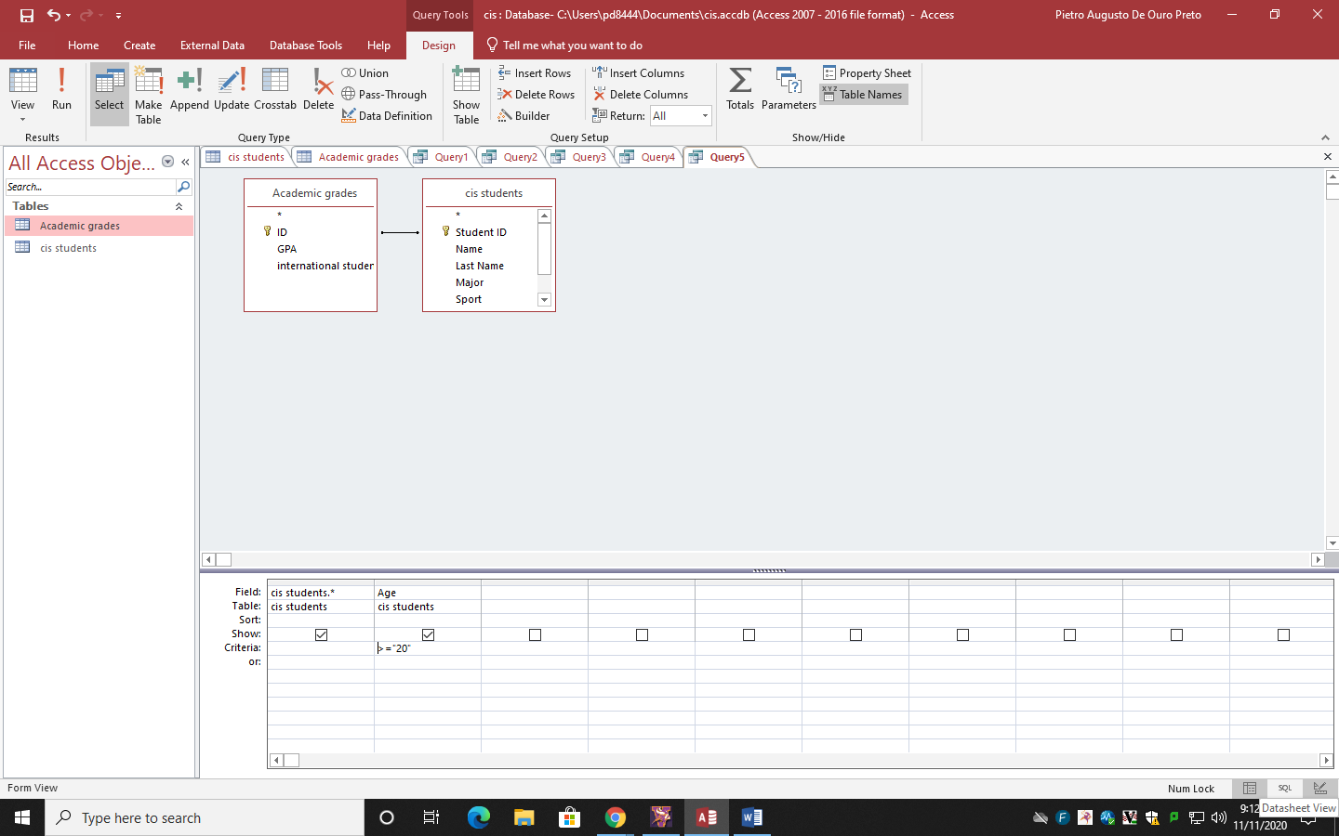14. The result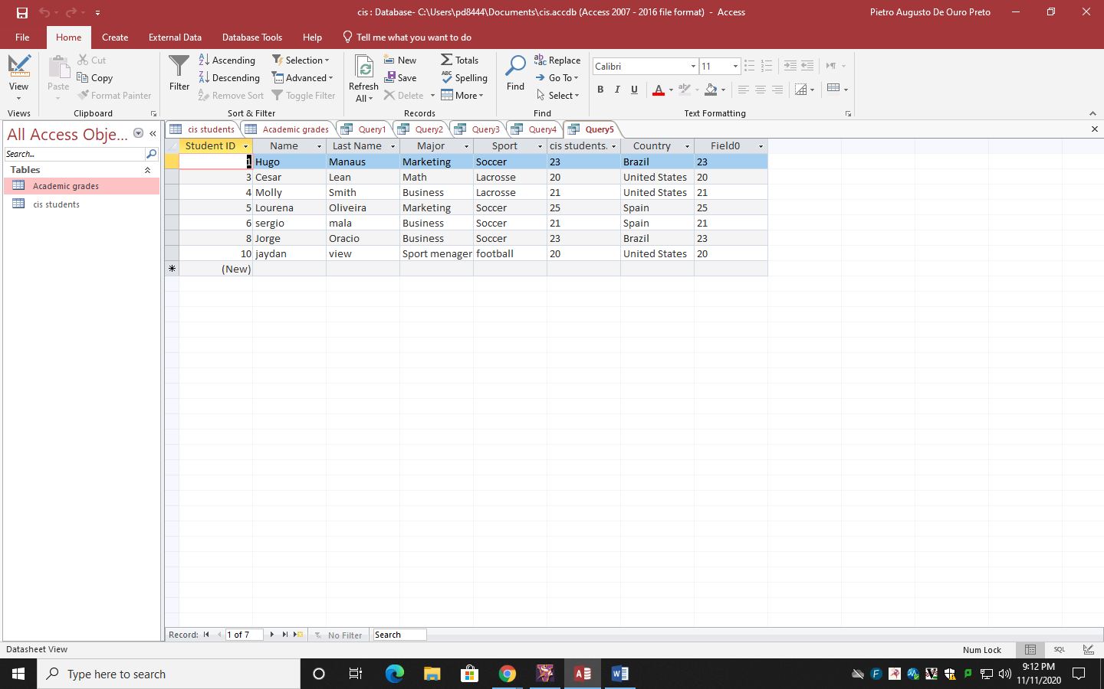

Conclusion

In this project I learned how to use the Microsoft Acess and how to create data bases.

After researching about it I understood what where the data base and how to use it,and after doing everything i can say that I the MA is really the best information management tool